Validation of the Navy Transport Models

Krzysztof Markowicz and Szymon Malinowski

Institute of Geophysics Warsaw University, Pasteura 7, 02-093 Warszawa, Poland,
phone: +48 (22) 5546-836 fax: +48 (22) 822 23 87 email: kmark@igf.fuw.edu.pl

Piotr Flatau
Scripps Institution of Oceanography, University of California, San Diego
La Jolla, CA92093
pflatau@ucsd.edu

N000140410519
http://www.igf.fuw.edu.pl

LONG-TERM GOALS

Our long-term goal is to improve global and regional predictive capability of Navy transport models.

OBJECTIVES

To better understand the role of atmospheric aerosols on health, air quality, and visibility on both global and regional scales. To improve forecasting of dust storms and dust plumes transport. Provide capability to forecast visibility and propagation characteristics of electromagnetic radiation at sea.

APPROACH

Atmospheric aerosols can have a marked impact on health, air quality, and visibility on both global and regional scales. Furthermore, the role of aerosols in the global energy budget and their estimated radiative forcing is modern and emerging topic. It is also known that dust storms occur frequently in and over many of the strategically important regions of the world: the Mid-East, Southwest Asia, East Asia, the Mediterranean Sea and the Atlantic and Pacific Oceans. These dust storms can have a negative impact on the strategic and tactical goals and operations of the U.S armed forces and sea-salt emissions in heavy weather conditions influence visibility and propagation characteristics of the electromagnetic radiation. Our research examines performance of the Navy global transport model for extended time period of several years, suggested improvements, and lead to implementation and characterization of new species in the model. This research closes important gap by allowing prediction of all major aerosol components at sea.

WORK COMPLETED

Several publications has been submitted to major journals and are in various stages of editorial process, 2 Ph. D. students are supported by this grant and they are now entering their last year of their study. Our group participated in the NRL deployment in the United Arab Emirates. We actively participated in NRL activities including 6.1 and 6.2 research objectives. We collaborated, including visits and model support, with the DoD Center for Geosciences/Atmospheric Research (CGAR) at Colorado State University which resulted in M. Sc., and are interacting with the NATO Undersea Research Centre in La Spezia, Italy.

We comprehensively characterized optical properties of aerosols in the coastal region of the United Arab Emirates. Our research shows importance of aerosols on regional climate change and weather and presents working hypothesis about aerosol-weather interaction in parts of the Middle East.

We developed comprehensive 7-years of global transport data based on NAAPS model re-runs, developed new parameterization for the sea-salt emissions, employed comprehensive data sets from in-situ observations at sea, and developed methodology and performed model validation for 28 land stations over several years.

PERSONNEL EXCHANGES AND TRAVEL COMPLETED

We collaborated with the Colorado State University CGAR collaboration. Mr Marcin Witek visited that group and worked with professor Sonia Kreidenweis. Mr Witek and Dr Flatau visited twice Naval Undersea Research Center in La Spezia, Italy (COAMPS transport). Trips to NRL allowed for extended discussions and software implementations.

Table 1. Summary of personnel exchanges and travel conducted under this NICOP.
Name | Home Institution | Institution / Location Visited | Scientific / Technical Purpose of visit | Dates (mm/dd/yy)
Marcin Witek | Institute of Geophysics UW | NRL | NAAPS model improvements | 7.02.2006 - 30.05.2006
Joanna Remiszewska | Polish Academy of Science | NRL | Preparation of the final version of the UAE2 paper | 20.03.2006 - 13.04.2006

RESULTS

Comprehensive validation of the Navy global transport model. Sea salt model and emissions.

Open ocean measurements of the sea salt concentrations from 5 different campaigns were used to improve the sea salt parameterization in NAAPS. Aerosol optical thickness information were derived from modeled mass concentration and compared to Aeronet observations. The data set is unique in that it is from open ocean shipboard measurements, which alleviates typical problems associated with surf zone on land stations. Employing a global forecasting model and transport model with detailed representation of dry and wet deposition, advection and diffusion tests the validity of the sea salt parameterizations. It was shown that inclusion of these processes leads to good agreement with shipboard measurements. Apart from wet deposition uncertainties, model-measurements discrepancies are found to be influenced uncertainties at strong wind speed regime, the lack of wind speed threshold for emission onset and the lack of size differentiation for deposition velocity. Model results, transformed to aerosol optical thickness, were validated against observations from selected sunphotometer observations and show good agreement. Global sea salt simulation for 7 years was conducted. Average annual sea salt emission is estimated to be about 3×10¹² [kg], which is in agreement with previous estimates.
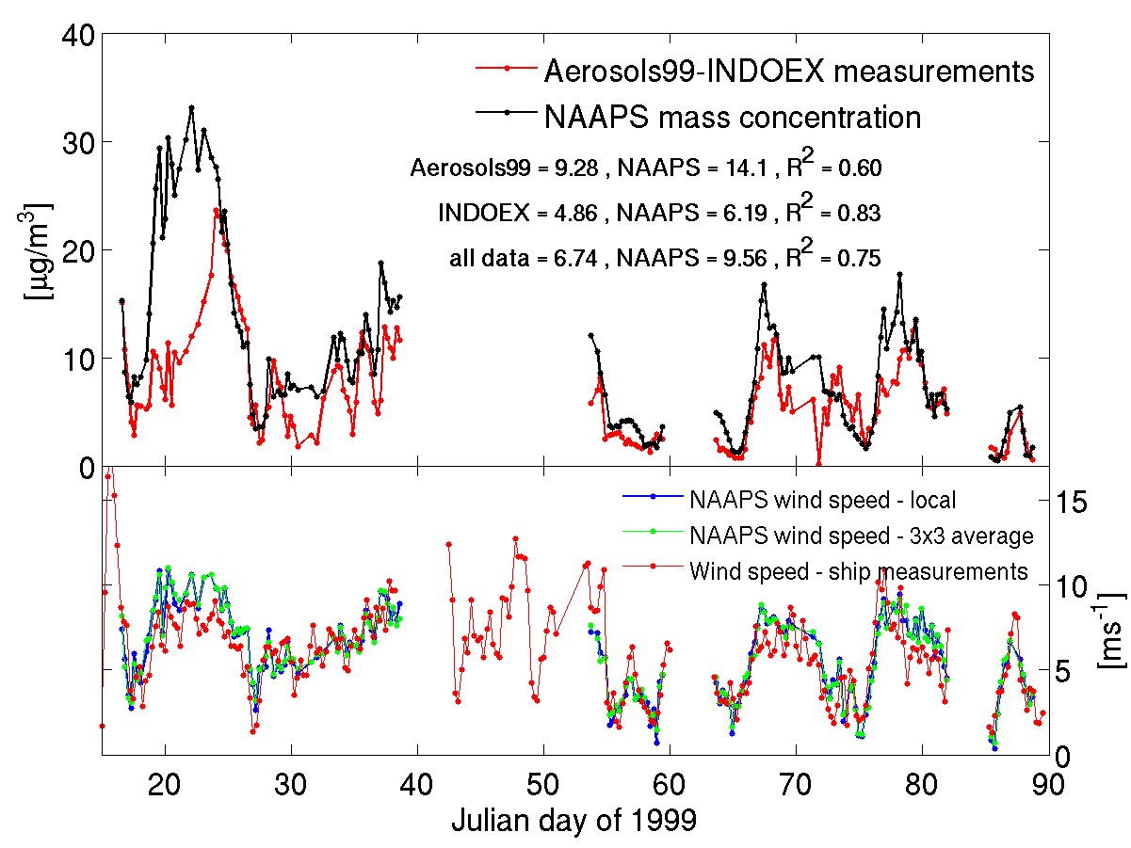
Comparison of the model concentrations with the measurements during the Aerosols-INDOEX99.

Comprehensive validation of the Navy global transport model. Validation against US sources and transport of dust from China.

Aerosol data from the Interagency Monitoring of Protected Visual Environments (IMPROVE) network was compared with NAAPS soil dust aerosol predictions to examine observations of soil dust over the continental U.S. from 2001 to 2004. Two model simulations were performed for this entire period: one in which all dust sources were active, and another in which North American dust sources were suppressed. Comparisons of the 2001-2004 NAAPS predictions of surface dust concentration to IMPROVE [PM10-PM2.5]+[Soil] measurements were carried out for 28 sites throughout the U.S. Relative frequencies of the model predictions that fell within a factor of two of the IMPROVE measurements were 39%, 45%, 33% and 30% for winter, spring, summer, and fall, respectively. The correspondence fared best in spring when NAAPS predicted the widest influence of non North American soil dust at the surface in the U.S. Overall, the model showed good skill at reproducing the timing and magnitude of Asian dust incursions in the U.S. in spring. However, median ratios of NAAPS-to-IMPROVE surface dust concentrations indicated a persistent bias toward ratios less than one at coastal and some inland sites. Further analyses using speciated IMPROVE PM10 data at select sites for 2004 indicated that many of these locations were impacted by sea salt and other sources of coarse-mode particulate matter that biased the IMPROVE soil estimate too high. Ratios greater than one were realized at other sites, depending upon on the season and site altitude. An examination of these occurrences suggested agreement between the NAAPS predictions and in situ data could be improved by adjusting the model transport and deposition schemes, and by incorporating snow cover data, variable threshold friction velocities, and agricultural sources of dust.

Characterization of aerosol scattering and absorption, its climate forcing role, and development of a conceptual model of aerosol – weather feedback in the coastal region of the United Arab Emirates.

The spectral aerosol absorption properties in the Arabian Gulf region were observed during the United Arab Emirates Unified Aerosol Experiment (UAE2). Measurements were taken at a coastal region of the Arabian Gulf located 60 km northeast of Abu Dhabi, the capital of the United Arab Emirates, allowing characterization of pollution and dust particle absorption properties in a highly heterogeneous environment. A large observed modulation of the diurnal signal was due to (a) strong sea- and land-breeze and (b) changes in prevailing large scale flow. During the night, stagnating air resulted in gradual accumulation of pollution with maximum absorption in the early morning hours. The rising sun increased both the depth of the boundary layer and the temperature of the interior desert, resulting in strong and sudden sea-breeze onset which ventilated the polluted air accumulated during the night. Our observations show that the onshore winds brought cleaner air resulting in decreasing values of the absorption coefficient and increasing values of the single-scattering albedo. The mean value of the absorption coefficient at 550 nm measured during the sea breeze was 10.2 Mm-1 while during the land breeze it was 13.8 Mm-1. Large scale transport also strongly influenced particle fine/coarse partition with "northern" flow bringing pollution particles and "southern" flow bringing more dust.

The aerosol radiative forcing in the Persian Gulf region is derived on basis of the data collected during the United Arab Emirates Unified Aerosol Experiment (UAE2). The land-sea breeze circulation modulates the diurnal variability of the aerosol properties and aerosol radiative forcing at the surface. Larger radiative aerosol forcing is observed during the land breeze in comparison to the sea breeze. The aerosol optical properties change as the onshore wind brings cleaner air. The mean diurnal value of the surface aerosol forcing during the UAE2 campaign is about -20 Wm-2 which corresponds to the large aerosol optical thickness (0.45 at 500 nm). The aerosol forcing efficiency is relatively small (-52 Wm-2) because of large aerosol optical thickness and high value of the average single scattering albedo (0.93). Five aerosol models are derived on the basis of the surface optical measurements and the AERONET sunphotometers retrievals. Comparison of the aerosol radiative forcing calculations based on these models show that the "spheroid" model gives the best agreement. The mean bias between the observations and the model is small (1.9 Wm-2) but the RMS error is significant (6.2 Wm-2). Radiative transfer calculations based on the AERONET aerosol optical properties show systematically larger aerosol forcing in comparison to observations. It is caused by the significant difference between asymmetry parameter calculated for the surface and columnar AERONET retrieval. The difference of the aerosol forcing between the "spherical" and the "spheroid" models is relatively small but important.

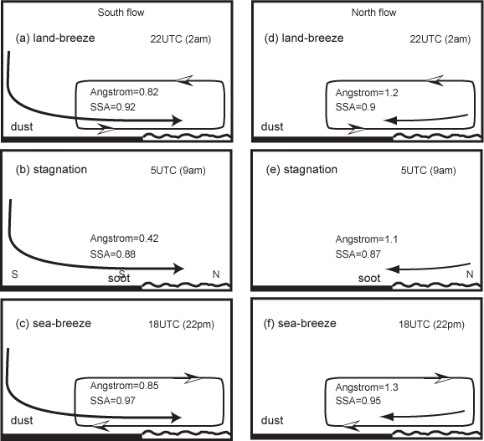

Conceptual model of regional and large scale weather impact on aerosol properties in the coastal region of the united Arab Emirates.

IMPACT/APPLICATIONS

Our research has both Navy and societal implications. It is directed towards better understanding of the role of atmospheric aerosols on health, air quality, and visibility on both global and regional scales. To improve forecasting of dust storms and dust plumes transport towards the continental US from China.

Our research examines performance of the Navy global transport model for extended time period of several years, suggested improvements, and lead to implementation and characterization of new species in the model. This research closes important gap by allowing prediction of all major aerosol components at sea.

TRANSITIONS

The sea-salt parameterization developed by us is now operational at NRL Monterey. The results are available daily via NRL home page http://www.nrlmry.navy.mil

RELATED PROJECTS
For these projects we worked closely with the Naval Research Laboratory in Monterey, California (UAE2 project; http://uae2.gsfc.nasa.gov/), Scripps Institution of Oceanography in San Diego, California (sea-salt characterization poject, the Naval Undersea Research Center in La Spezia, Italy (COAMPS transport), as well as the DoD Center for Geosciences/Atmospheric Research (validation of NAAPS, and transport of dust from China).

REFERENCES

Remiszewska, J., P. J. Flatau, K. M. Markowicz, E. A. Reid, J. S. Reid, and M. L. Witek (2006), Modulation of the aerosol absorption and single-scattering albedo due to synoptic scale and sea breeze circulations: United Arab Emirates experiment perspective, J. Geophys.
Res., doi:10.1029/2006JD007139, in press.

Markowicz, K. M, P. J. Flatau, J. Remiszewska, E. A. Reid, J. S. Reid, A. Bucholtz, B. Holben, and M. L. Witek (2006), Observations and modeling of the surface aerosol radiative

forcing during the UAE² experiment. J. Geophys. Res., in review.

Markowicz, K. M, P. J. Flatau, A.E. Kardaś, K. Stelmaszczyk (2006), Retrieval of the aerosol extinction and backscatter coefficient profiles using ceilometer, in preparation.

Witek, Marcin L., Piotr J. Flatau, Patricia K. Quinn and Douglas L. Westphal (2006). Global sea salt modeling – results and validation against multi-campaign shipboard measurements. J. Geophys. Res, in review.

Kelley C. Johnson, A comparison of the Navy Aerosol analysis and prediction system (NAAPS) to in-situ aerosol measurements in the continental US: transport vs. local production of soil dust aerosol, 2006, Colorado State University, Fort Collins, Colorado, M. Sc. Thesis.

Kelley C. Johnson, Marcin Witek, Piotr Flatau, Sonia M. Kreidenweis, and Douglas A. Westphal, Surface dust aerosol concentrations in the western U.S.: Comparison of model predictions and observations, in preparation, 2006, in preparation, manuscript available, 30 pages.

