SGR-NAAPS Contrast Transmittance Model

Krzysztof Markowicz
Institute of Geophysics Warsaw University, Pasteura 7, 02-093 Warszawa, Poland
phone: +48 (22) 5546-836 fax: +48 (22) 822 23 87 email: kmark@igf.fuw.edu.pl

Szymon Malinowski
Institute of Geophysics Warsaw University, Pasteura 7, 02-093 Warszawa, Poland
phone: +48 (22) 5546-860 fax: +48 (22) 822-2387 email: mailna@igf.fuw.edu.pl

N000140410519
http://www.igf.fuw.edu.pl

LONG-TERM GOALS

Our long-term goal is to improve global and regional predictive capability of transport of dust and aerosols, and to use this capability to study the interaction between aerosols and weather.

OBJECTIVES

Our objectives are to develop diagnostic codes which predict visibility parameters as well as diagnose aerosol forcing.

APPROACH

We developed an interface between the state-of-the-art radiative transfer codes (Fu-Liou) and NAAPS/NOGAPS fields and develop the surface albedo and the emissivity characterization for use in these codes. We will develop a software package to study the slantwise visibility and contrast using path radiance calculations based on the NAAPS/NOGAPS aerosol and dust predicted concentrations.

WORK COMPLETED

We completed the state-of-the-art radiative transfer codes based on NAAPS/NOGAPS fields and contrast transmittance model based on Sky-to-Ground-Ratio model.

PERSONNEL EXCHANGES AND TRAVEL COMPLETED

Table 1. Summary of personnel exchanges and travel conducted under this NICOP.
Name | Home Institution | Institution / Location Visited | Scientific / Technical Purpose of visit | Dates (mm/dd/yy)
K. Markowicz | Institute of Geophysics UW | NRL | Develop NetCDF interface NAAPS | 01/01/04-01/30/04

RESULTS

- The NetCDF interface to NAAPS and NOGAPS
We assisted in development and tests of the NetCDF interface to the Naval Aerosol Analysis and Prediction System (NAAPS) and for Naval Operational Global Atmospheric Prediction System (NOGAPS) codes to facilitate an easy and convenient way to analyze the NAAPS model output. Till late 2003 all NAAPS history files were written from the FORTRAN using the binary sequential format. These formats files have been written in mix of singe and double precision. Currently, the NetCDF is created from these single precision files in a post processing mode. The NAAPS history binary files contain concentrations of gases (SO2) and aerosols (SO4,dust, smoke), information about coordinates, as well as information about the surface pressure, terrain height, selected meteorological parameters. The NOGAPS and NAAPS history file provide subset of the meteorological information needed for the NAAPS runs and are derived form the NOGAPS history. Another part of the design philosophy is to facilitate use of the Grid Analysis and Display System (GrADS) which is interactive desktop tool that is used for easy access, manipulation, and visualization of earth science data.

- Application of the Fu-Liou radiative code to NAAPS model
We developed an interface between the state-of-the-art radiative transfer code Fu-Liou (1992,1993) and NAAPS/NOGAPS fields. This interface allows to determine radiative fluxes in the atmosphere and estimate the aerosol forcing at the top of the atmosphere and at the Earth’s surface. We use the 0602 version of the Fu-Liou code which includes delta 2/4 streams (for shortwave and longwave range) solver developed by Fu & Liou (1992,1993). This code is used to calculate fluxes for pristine and aerosol condition without clouds. Vertical profiles of pressure, temperature, and relative humidity are taken from NOGAPS model. Currently NOGAPS output file includes 24 vertical layers.
One of the most important parts was developed is on aerosol optical model based on NAAPS transport model. Our aerosol model built based on OPAC/GADS (Hess, et. al. 1998) database. It includes four aerosol components: sulfates, dust, soot, and water soluble. Because NAAPS model doesn’t have soot and water soluble particles therefore we use relation
$$m_{\text{smoke}}=0\text{.}\text{05}m_{\text{soot}}+0\text{.}\text{95}m_{\text{ws}}$$
where m_{smoke}, m_{soot,} m_{sw} are a mass concentration for smoke, soot, and water soluble particles respectively. Based on this equation the smoke single scattering albedo was estimated in range 0.89 to 0.93 depends on the relative humidity. From vertical profiles of mass concentration (NAAPS output) we calculated particle number density and next optical properties of aerosol external mixture.
Aerosol radiative forcing is very sensitive to surface albedo therefore we develop two surface models: first CERES/SARB albedo-emissivity model (http://www-cagex.larc.nasa.gov/surf/index.html) and second USGS model based on Global Land Cover Characteristic Data Base). The first model, which include twenty surface categories we use for surface emissivity computations important for longwave fluxes. Second model (based on AVHRR observation) we use for spectral albedo estimation over one hounded surface types. In both model we modify original surface properties due to snow cover (Zhou et al., 2003) based on snow information from NOGAPS model.
Since, ozone concentration are not very responsive to radiation fluxes we use ozone vertical profiles from three dimensional climatology, UGAMP (Li et al.,1995).
Briefly described above code includes following files:

- readnaaps.f - to read NetCDF NAAPS file
- readnogaps.f - to read NetCDF NOGAPS file
- readusgs.f - to read the USGS database and to calculate surface albedo
- readozone - to read ozone climatology
- writenc.f - to write output data to NEtCDF file
- albedo_emiss.f - to read the SARB database and to calculate surface albedo and emissivity
- aerosol_kmark.f90- to calculate aerosol optical properties
- time_sub.f - calculates data and time from Julian Day
Fig. 1 shows the aerosol forcing at the top of the atmosphere at 12 UTC (Nov 20, 2003). Note that instantaneous values are presented. At this instant aerosol forcing over Pacific Ocean is zero. Aerosol forcing over the Central Europe is negative due to sulfates present. In contrast dust over large albedo surface over Northern Africa gives positive aerosol forcing at the top of the atmosphere.
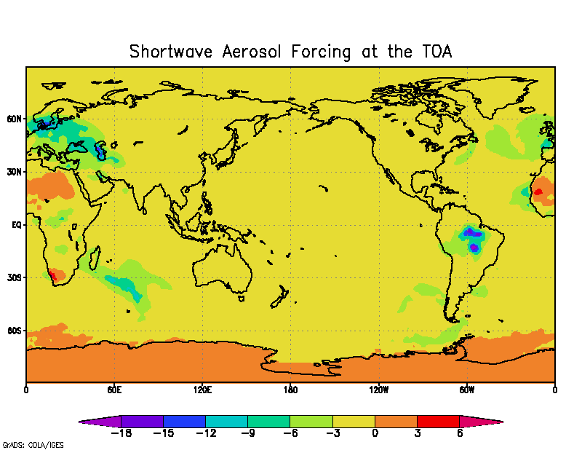
Fig.1. Shortwave aerosol forcing at the top of the atmosphere on Nov 20, 2003, 12:00 UTC

3. Contrast Transmittance model
In this part we describe a driver code, which use NAAPS and NOGAPS and radiative transfer model based on the Sky to Ground Ratio (SGR) (Brien et al.) to define the contrast transmittance and related visibility parameters. This code can be used to study information on regional, local, and global scale contrasts at varying viewing angles, target locations, pre-defined wavelengths in solar, near-IR, and IR window regions. In the solar spectrum the radiative transfer model is based on the delta-Eddington approximation (Joseph et al.,1976). The SGR defines set of standard atmospheres and aerosol models, and uses surface visibility to define the total aerosol extinction.
This code consists of three parts: (a) the main program with NOGAPS-NAAPS reader and albedo model codes, (b) the SGR code, and (c) the Graphical User Interface (GUI) written in Matlab. The GUI is independent from main code. The main program reads the text input file, which defines time, geographic at information, the geometry, the spectral range, and NOGAPS and NAAPS input files (saved in the NetCDF format). After reading an input file the main program reads in NOGAPS the file in the NetCDF format. Atmospheric profiles and surface types in each grid point are obtained from NOGAPS run. The surface information is used to define the albedo and the emissivity. To do this we used the CERES-SARB albedo model. The albedo is one of the parameters used by the SGR to calculate contrast transmittance in the solar spectrum. Solar zenith and azimuth angles are calculated and the aerosol information is read-in from the NAAPS NetCDF file. Vertical profiles of aerosol mass concentration for sulfates, smoke and dust particles are used to calculate the optical properties based on the OPAC database. There is sea salt parameterization based on the surface wind speed and the ocean fraction. Thus, for each geographic position we have vertical profiles of aerosol extinction and columnar-averaged single scattering albedo. The single scattering albedo is used to pick one of four standard SGR aerosol models. These models are: marine, rural, urban, and tropospheric aerosol type. We also choose one of six standard atmospheric profiles on the basis of total precipitable water.
The SGR model is executed inside loops over: time, longitude, latitude, LOS zenith and azimuth angles, target and observer altitude, and wavelength. An input to the SGR code is generated by the driver code. This file defines geometry and spectrum range. The output from SGR is also in text format and is read-in after each of the SGR calls.

3.1 The Sky-to-Ground-Radio model.
This code is based on the SGR4.0 version program with slight modifications. We modified the vertical profile of the aerosol extinction in VISDRIVE subroutine. Instead of the aerosol extinction profile based on the surface visibility and height of the haze layer our vertical profile is based on the NAAPS model and the OPAC database. We added the aerosol extinction and the relative humidity profile to the standard SGR input file and these variables are read in by the SGRDRIVER routine.
Since the solar position is calculated independently of the SGR we removed C routines calculating solar and moon zenith and azimuth angles. This makes the package more portable because it is all in Fortran 90.
There is an input switch in the SGR code to define the choice of the spectral range: (a) visible, (b) mid-infrared, and (c) far-infrared. The visible part includes multiple scattering processes and is based on the delta-Eddington approximation. Although both visible and infrared contrast transmittance depends on the aerosol properties only in the solar spectrum aerosols effect is significant.

3.2 The Graphical User Interface
We developed graphical user interface (GUI) in Matlab version 6.5 (release 13). The GUI allows specify to define all input parameters, execute SGR, plot and display results. The input parameter can be specified in several dialog boxes or loaded from Matlab binary file. In the first option user chooses time (year, month, day, hour minute) and geographic region. The geographic region is defined by minimum and maximum latitude and longitude. When the maximum and minimum value are the same program calculates contrast visibility for one point. The user can define NOGAPS and NAAPS NetCDF files. After clicking the browser is opened and one can specify a file. The geometry is defined by (a) LOS zenith and azimuth angle and (b) target and observer altitudes. The LOS zenith angle equal to 180 degrees corresponds to downward and 0 degrees to upward Line of Sight. The last one group of input parameters defines optional detector response file name, which can be selected from browser. One can also define spectral information. User can specify spectrum range (visible and/or mid-IR and/or far-IR) or prescribe wavelengths. All of these variables can be loaded also from Matlab binary file (*.mat).
User can modify this structure and save it in MAT file which should facilitate fast definition of slightly modified input to SGR. Note that time, LOS zenith and azimuth angles, target and observer altitude, as well as NOGAPS and NAAPS files can be stored as arrays. After the input parameters are defined one can run the SGR code. There is some error checks implemented. When the main program finishes its calculations the GUI provides information and can be used to plot contour and line plots.
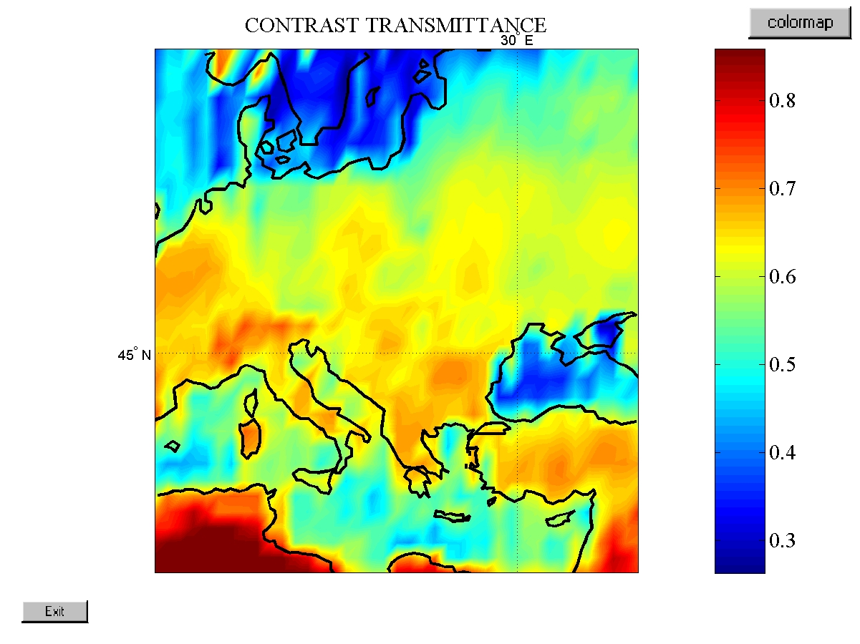
Fig. 2 Contrast transmittance for wavelength 0.5 μm over central part of Europe

The GUI can be used to plot six cases: time series, contrast for a geographic region, polar plot of contrast as a function of LOS geometry, target altitude, observer altitude, and spectral information. Similarly, sky to ground ratio, contrast transmittance, transmittance, path radiance and background radiance can be displayed. One has to specify a plot type and the variable name as well as other relevant variables. Note that all variables are stored in 8 dimensional matrices and for a two-dimensional plot 6 variables have to be defined. For example, for time series one should specify longitude, latitude, LOZ zenith and azimuth angles, target and observer altitude, and wavelength.
If time variable is scalar the GUI will show value of specified variables instead of generating a plot. For the “geographic region” plot we display a pseudo color map together with coastline (only if you have Matlab mapping toolbox). One can change the colormap using Matlab colormap editor. One can also plot variables using polar coordinates. The phi angle corresponds to the LOS azimuth angle and radius to the zenith angle. Note that for the downward geometry we changed the zenith angle and 0º corresponds to direct downward and 90º is at the horizon. One can plot up and down LOS cases separately. One can also visualize the spectral dependence of contrast transmittance and other variables.
For example Fig. 2 a shows sample of the “geographic region” plot of contrast transmittance. Low values over the Mediterranean are associated with low albedo and some variability is due to changes in the aerosol optical thickness. Fig.3. shows that contrast transmittance decreases strongly towards the horizon because of increasing path radiance.

3.3 Limitation and uncertainties
The SGR solver for the solar spectrum is based on the delta-Eddington approximation, which approximates the sky radiance distribution Although this approximation is significantly worst than that calculated by MODTRAN/DISORT the larger source of uncertainty in the solar spectrum (0.35-0.75 μm) are aerosol models and surface albedo. The aerosol single scattering albedo and phase function are predefined for 4 only aerosol types. The SGR albedo is spectrally flat. In the visible spectrum no gaseous absorption is considered. The SGR model has a fixed top of the atmosphere at the 10 km and the surface is always at the mean sea level. This limits current model applicability. At present, the target and observer altitude should be between 0 and 5 km.
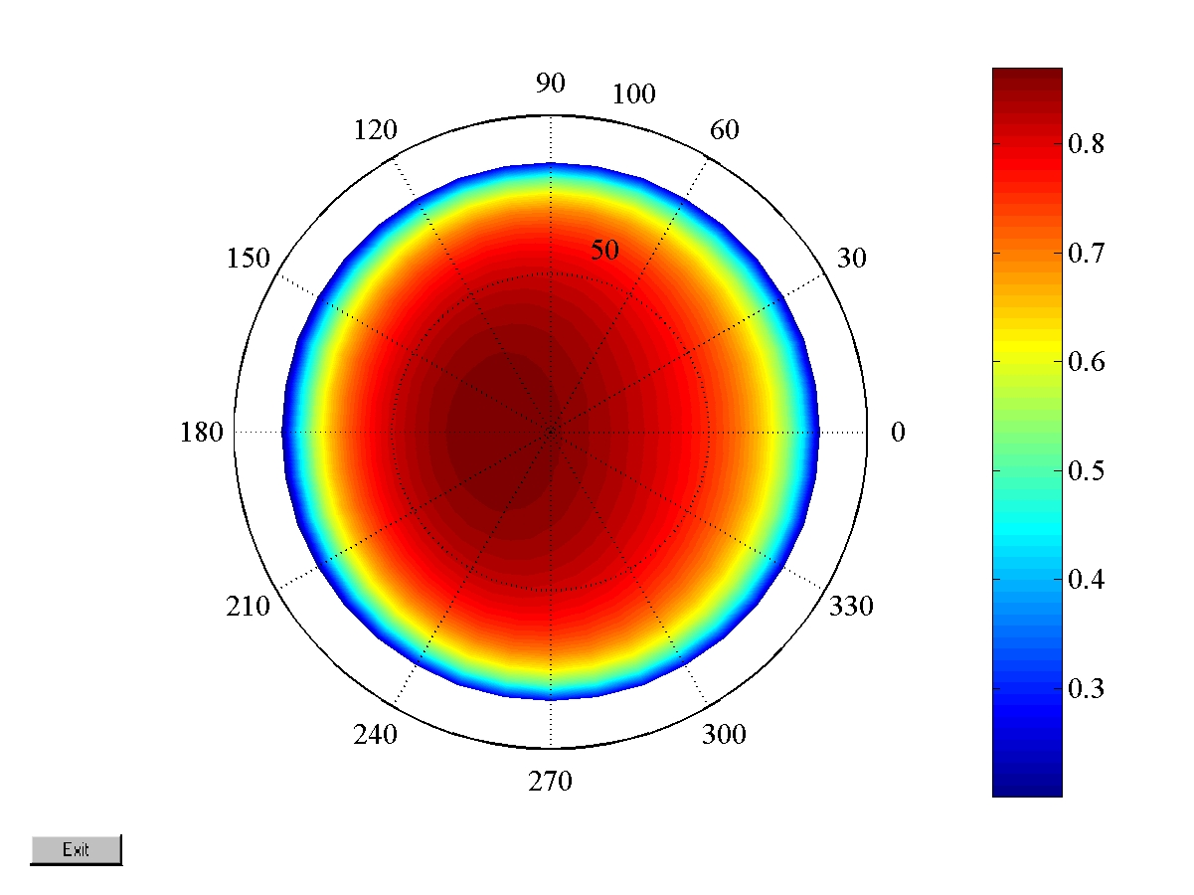
Fig. 3 Contrast transmittance as a function of the azimuth and zenith angle for downward line of sight (LOS).

The infrared calculations are limited mostly by the choice of fixed atmospheric profiles and definition of the surface emissivity. Prescription of the water vapor profile can produce significant errors in the infrared contrast and so can do incorrect choices of the surface emissivity. The SGR model assumes constant value of surface emissivity equal to 1. This can be improper assumption for certain types of surfaces such as a desert.

IMPACT/APPLICATIONS

The state-of-the-art radiative transfer model (Fu-Liou) allows study aerosol forcing in scale of the globe. Contrast transmittance model can be applied to visibility forecasting and use in many applications.

TRANSITIONS

All results are directly impact the Navy's aerosol forecasting capability since we will work closely with NRL/ARMS and their NAAPS transport models.

RELATED PROJECTS

REFERENCES

- Joseph, J.H., W.J. Wiscombe, J.A. Weinman, “The Delta-Eddington Approximation for Radiative Flux Transfer,” JAS, pp 2452, v33, December 1976.
- Fu, Q., and K. N. Liou, 1993 : Parameterization of the radiative properties of cirrus clouds, J. Atmos. Sci., 50, 2008-2025.
- Fu, Q., and K. N. Liou, 1992: On the correlated k-distribution method for radiative transfer in nonhomogenous atmospheres, J. Atmos. Sci., 49, 2139-2156.
- Hess, M., P. Koepke, and Schult, Optical properties of aerosol and clouds: The Software Package OPAC. Bulletin of the American Meteorology Society, vol. 59, 831-844, 1998.
- Li, D., and K. P. Shine, 1995, A 4-Dimensional Ozone Climatalogy for UGAMP Models, UGAMP Internal Report, No. 35, April 1995.
- Stamnes, K., S. C. Tsay, W. Wiscombe and K. Jayaweera, 1988, Numerically stable algorithm for discrete-ordinate-method radiative transfer in multiple scattering and emitting layered media, App. Opt. ,27, 2502-2509.
- Zhou, L, R.E. Dickinson, Comparison of aerosol seasonal and spatial variations of albedo form MODIS doi:10.1029/2002JD003326,2003.
- Brien Sean G, R.C. Shirkey, Determination of atmosphere path radiance: Sky-to Ground Ration for Wargamers, http://www.nrlmry.navy.mil/bacimo2003/proceedings/9-05%20Shirkey.doc

